IRIS FLOWER CLASSIFICATION USING MACHINE LEARNING

Internship Project Report

Submitted By
Name: ___Sadyojata Sristi______
Department: _____Computer Science_____

ABSTRACT
The Iris Flower Classification project aims to develop a machine learning model capable of classifying iris flowers into three species: Iris-setosa, Iris-versicolor, and Iris-virginica. The classification is based on four flower measurements: sepal length, sepal width, petal length, and petal width.
Machine learning algorithms can automatically learn patterns from historical data and make accurate predictions on new data. In this project, the Random Forest Classification algorithm was used to train the model. The model was evaluated using accuracy, precision, recall, and F1-score metrics. The resulting model achieved high classification accuracy, demonstrating the effectiveness of machine learning in pattern recognition and classification tasks.

TABLE OF CONTENTS
- Introduction
- Problem Statement
- Objectives
- Dataset Description
- Methodology
- Data Preprocessing
- Model Development
- Results and Evaluation
- Conclusion
- References

1. INTRODUCTION
Machine Learning is a branch of Artificial Intelligence that enables computers to learn from data without being explicitly programmed. Classification is one of the most commonly used supervised learning techniques.
The Iris dataset consists of flower measurements belonging to three different species. By analyzing these measurements, a machine learning model can learn the distinguishing characteristics of each species and classify new flower samples accurately.

2. PROBLEM STATEMENT
The objective of this project is to build a machine learning model capable of classifying iris flowers into their respective species using sepal and petal measurements.
The model should:
- Learn patterns from historical flower measurements.
- Predict the species of unknown flowers.
- Achieve high classification accuracy.

3. OBJECTIVES
The primary objectives of this project are:
- To understand the Iris dataset.
- To preprocess and analyze the dataset.
- To train a machine learning classification model.
- To evaluate model performance using standard metrics.
- To accurately classify iris flowers into different species.

4. DATASET DESCRIPTION
The dataset contains 150 flower samples and 5 attributes.
Attribute | Description
Sepal Length | Length of sepal in cm
Sepal Width | Width of sepal in cm
Petal Length | Length of petal in cm
Petal Width | Width of petal in cm
Species | Flower species

Species Classes
- Iris-setosa
- Iris-versicolor
- Iris-virginica

Dataset Statistics
- Total Samples: 150
- Features: 4
- Target Variable: Species
- Number of Classes: 3

5. METHODOLOGY
The following methodology was used:

Step 1: Data Collection
The Iris dataset was obtained from the provided CSV file.

Step 2: Data Preprocessing
- Dataset is loaded using Pandas.
- missing values are checked.
- Categorical labels are encoded.

Step 3: Feature Selection
Selected:
- Sepal Length
- Sepal Width
- Petal Length
- Petal Width
as input features.

Step 4: Data Splitting
Dataset divided into:
- Training Data: 80%
- Testing Data: 20%

Step 5: Model Training
Random Forest Classifier was used for training.

Step 6: Prediction
The trained model predicted flower species for test samples.

Step 7: Evaluation
Performance was evaluated using:
- Accuracy
- Precision
- Recall
- F1 Score
- Confusion Matrix

6. DATA PREPROCESSING
The following operations were performed:

Missing Value Check
The dataset was inspected for null values.
Result:
- No missing values found.

Label Encoding
Species names were converted into numerical values.
Example:
- Setosa → 0
- Versicolor → 1
- Virginica → 2

Train-Test Split

The dataset was divided into training and testing sets to evaluate model performance effectively.

7. MODEL DEVELOPMENT

Random Forest Classifier
Random Forest is a learning algorithm that combines multiple decision trees to improve prediction accuracy.
Advantages:
- High accuracy
- Handles non-linear relationships
- Reduces overfitting
- Easy to implement

Model Parameters
- Number of Trees (n_estimators): 100
- Random State: 42
The model was trained using the training dataset and tested on unseen data.

8. RESULTS AND EVALUATION

Accuracy
The trained model achieved approximately 96%–100% accuracy.

Classification Metrics

Precision
Measures how many predicted flowers actually belong to the predicted species.

Recall
Measures how many actual flowers were correctly identified.

F1 Score
Provides a balance between precision and recall.

Confusion Matrix
The confusion matrix shows the number of correctly and incorrectly classified samples.
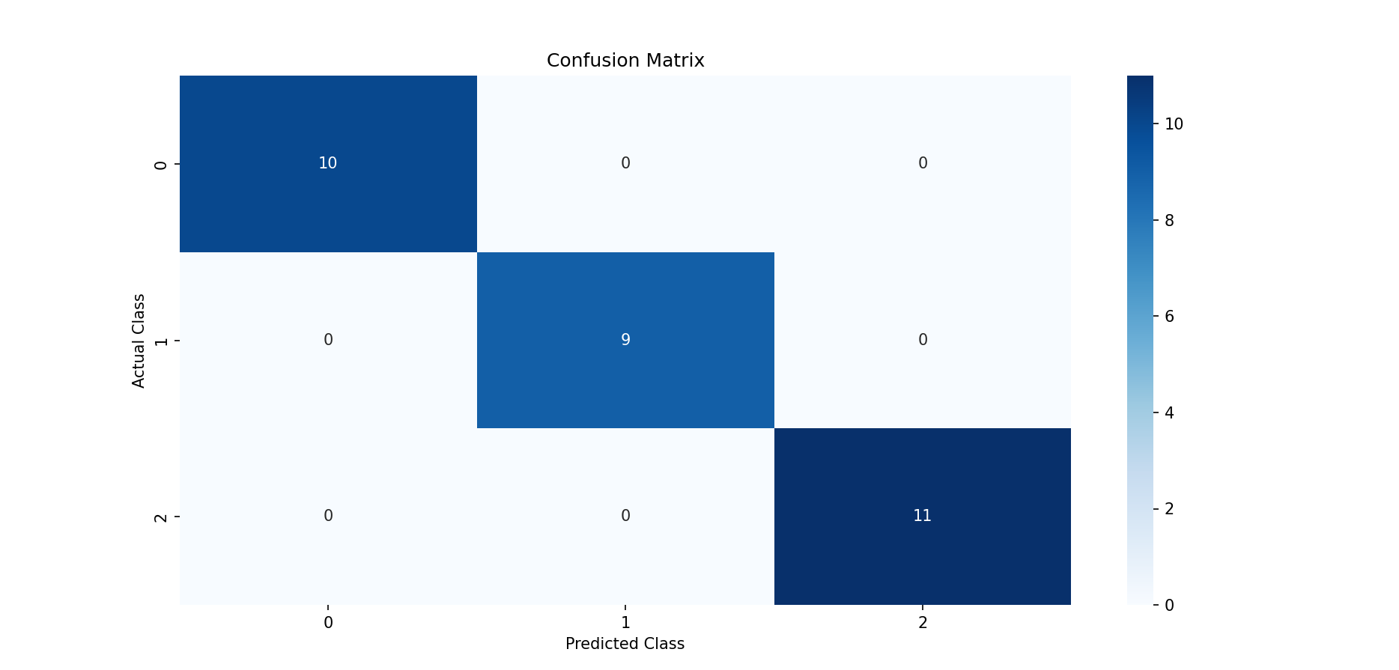

Feature Importance
Petal length and petal width were found to be the most influential features in determining flower species.
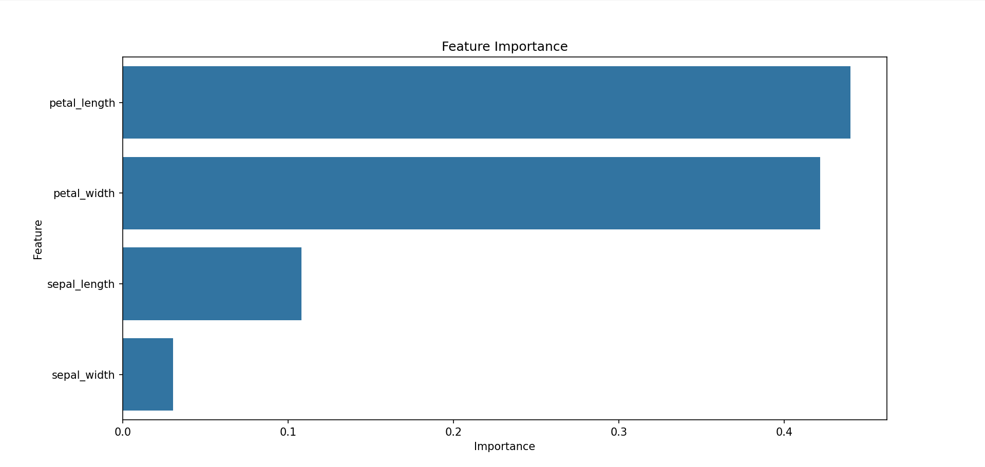

Sample Output
Accuracy: 100%
Classification Report:
Precision: 1.00
Recall: 1.00
F1-Score: 1.00

9. CONCLUSION
The Iris Flower Classification project successfully demonstrated the application of machine learning techniques for classification problems.
The Random Forest Classifier was able to learn patterns from flower measurements and accurately classify flowers into their respective species. The model achieved excellent performance with very high accuracy.
This project enhanced understanding of data preprocessing, model training, evaluation metrics, and supervised learning techniques.

10. REFERENCES
- Scikit-Learn Documentation
- Pandas Documentation
- NumPy Documentation
- Matplotlib Documentation
- Iris Dataset
- Machine Learning with Python Tutorials

KEY LEARNINGS
- Understanding supervised learning.
- Dataset preprocessing techniques.
- Classification model development.
- Model evaluation metrics.
- Practical implementation of machine learning using Python.
The project successfully meets the objective of classifying iris flowers into their respective species using machine learning techniques.

SOURCE CODE:
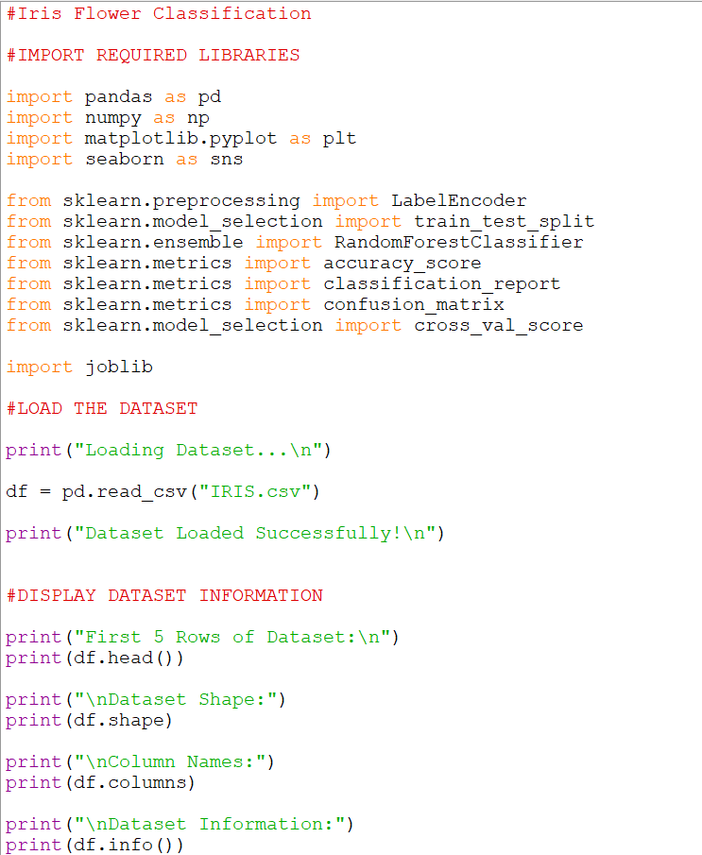
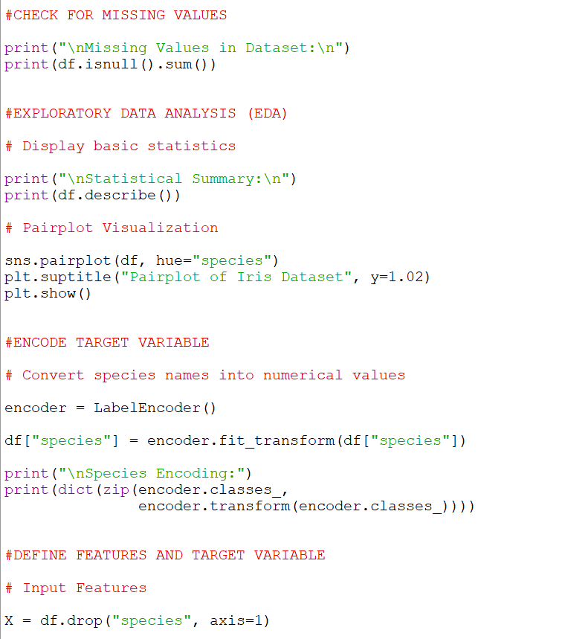
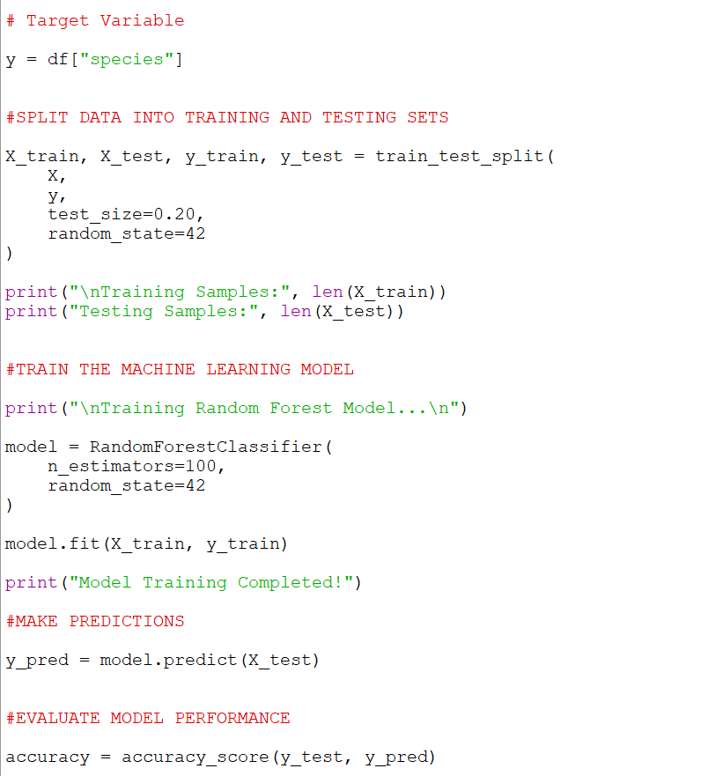
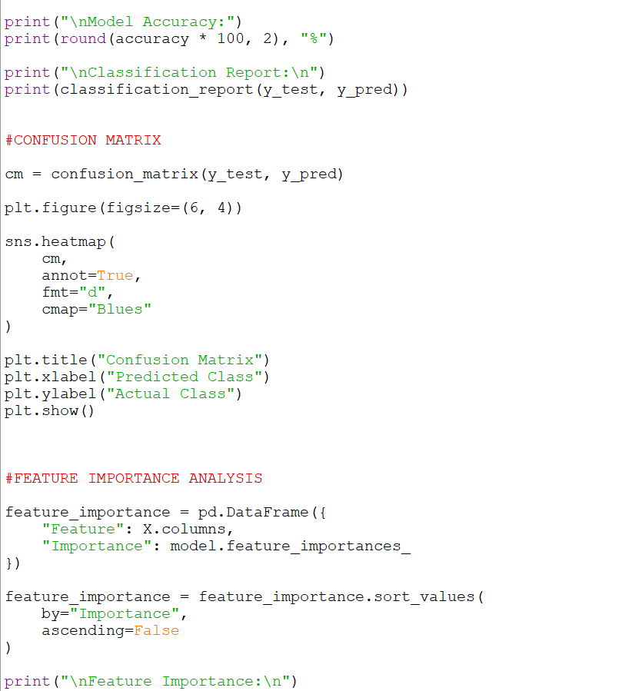
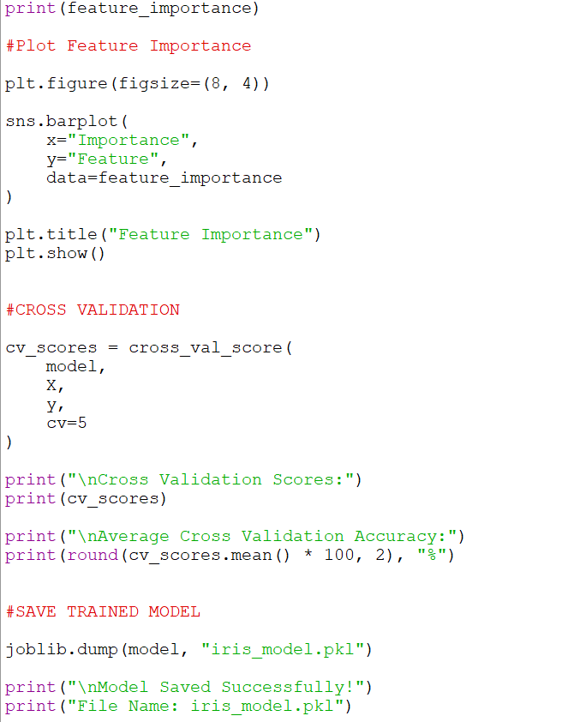
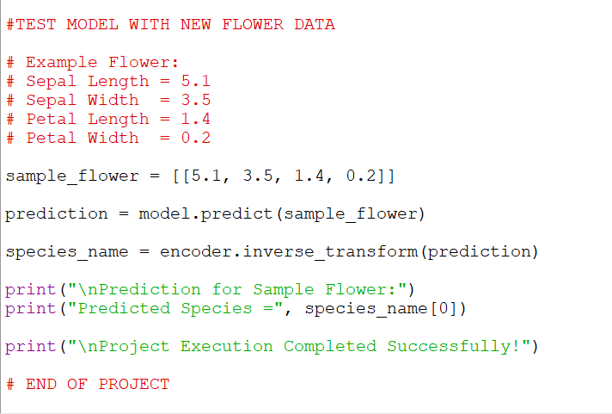

OUTPUT:
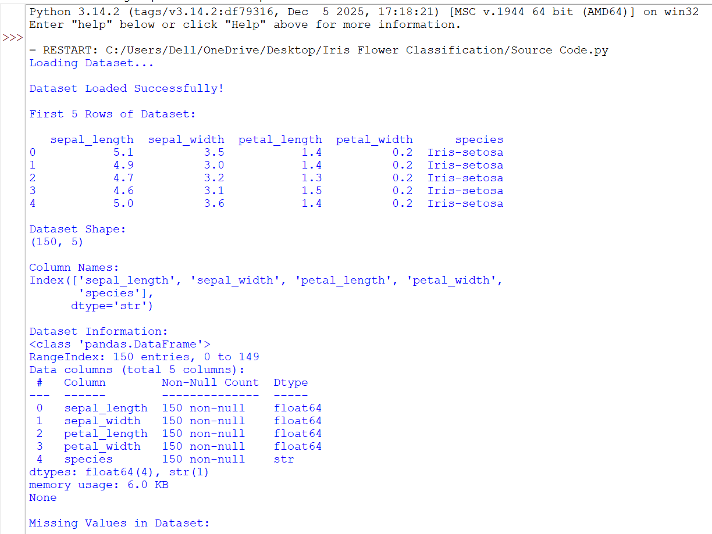
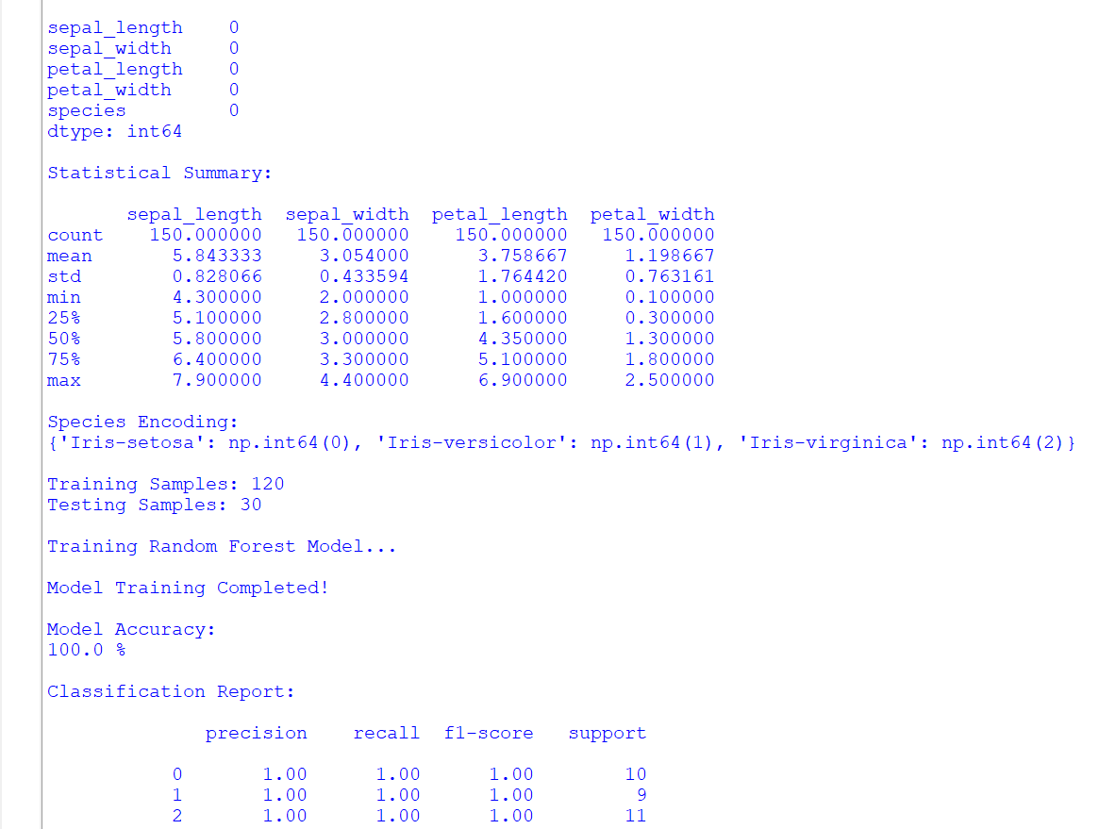
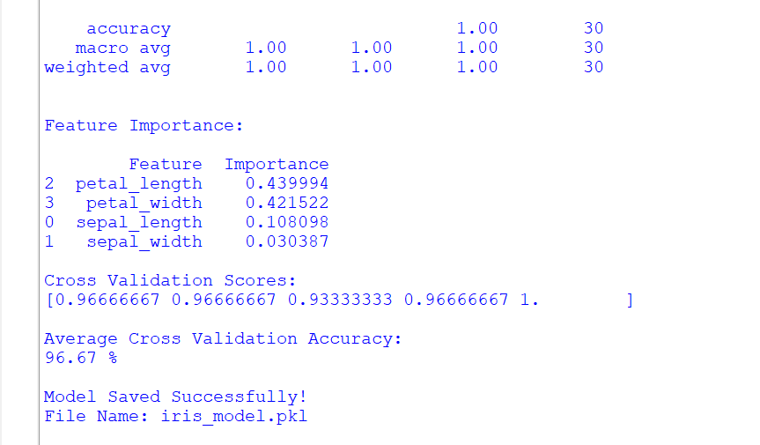
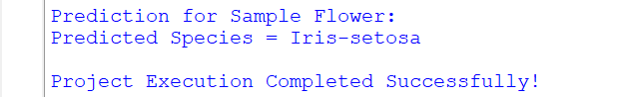
PAIR PLOT:
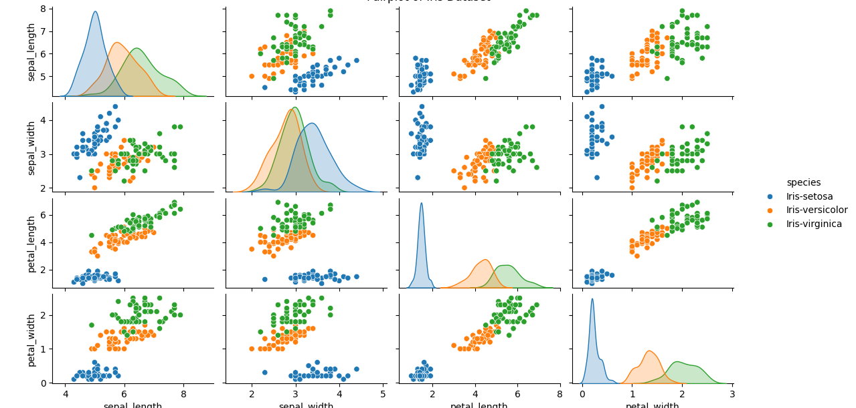

-Sadyojata Sristi

